Specs:

* We get a whole library with code which we’ll have to use
* We can’t use our own code for some certain subtasks, only the one provided for us

**Task 1:**

1a:

(We need to use the code provided from the MIT library)

We need to create a software which calculates the fastest way from one station to another

The stations are given by the user

We can use djikstra algorithm for calculating

As a requirement we need to list all the stations which were used to get in the fastest way from station X to station Y

1b:

Also create a histogram of the journey times in minutes, example:

Histogram - a diagram consisting of rectangles whose area is proportional to the frequency of a variable and whose width is equal to the class interval.

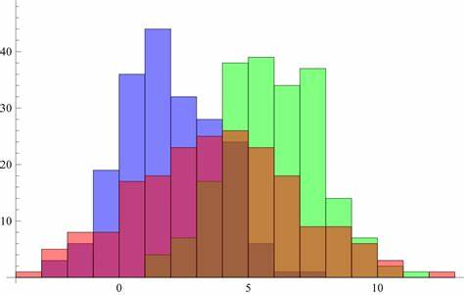

[style - Histogram with the smaller bar in front - Mathematica Stack ...](http://mathematica.stackexchange.com/questions/109717/histogram-with-the-smaller-bar-in-front) by Unknown Author is licensed under [CC BY-SA](https://creativecommons.org/licenses/by-sa/3.0/)

**Task 2:**

2a:

(We need to use the code provided from the MIT library)

Same as task 1a, but instead of showing the duration in minutes, we show the number of stations passed

2b:

Create a histogram of the journey times in the count of stations or

Stops

**Task 3:**

3a:

(We need to use the code provided from the MIT library)

Do the same as in task 1 and 2 but using a different algorithm library code

3b:

Create a histogram of the journey times in the count of stations or

Stops

**Task 4:**

4a:

(We need to use the code provided from the MIT library)

DIscusss!!!!

Kinda complex

We have one month!!!!!!!